
A Guide to Glove Reduction in Primary Care

This is a step-by-step guide to take you through the 5 stages of the Primary Care Glove Reduction Training as approved by the CIoS ICB Infection Prevention and Control team.
- Questionnaire 1: Send the Glove Use Questionnaire to all staff with a clear expectation of when it needs to be completed by (suggested two weeks or less). Email annettee@volunteercornwall.org.uk when you send it and when the deadline is.

- Training: Complete the Primary Care Glove Reduction Training – using the PowerPoint. This can be done in small teams or departments, or as part of a whole practice closure day.

- Display posters: for both staff and patients. These can be edited and bespoke to your practice.

- Questionnaire 2: Send the Glove Use Questionnaire again to compare usage from before the training.

- Procurement Data: Compare orders of gloves before the training to afterwards. E.g. if you finish in June, compare June this year to the number of orders last June. You could choose a 3-month period or longer to gather a more comprehensive picture.
Resources:
Questionnaire – this will be tailored to your practice and is to be completed by all staff within a 2-week (or less) window. The Primary Care Climate Resilience Team will provide the link to the Microsoft form. It takes about 2-3 minutes to complete the 25 questions about when gloves should be worn. The team will analyse the data ready for your training day(s).
Training PowerPoint – 18 slides including a few short video clips. I’d encourage this to be viewed in groups with some time to allow discussions. All staff should be involved. The Primary Care Climate Resilience Team can support you in person with this training as necessary. Allow a minimum of 30 mins for the training, ideally 45 mins to one hour would provide time for full discussions.
Posters & Screens – there are template designs that can be edited to suit your practice. See below for examples.
Time commitment:
Total time for all staff – one hour (including 2 questionnaires at 2-3 mins each time).
Admin time = organisation of the staff training and time for sending the questionnaire (and reminding people to complete it). Estimated half an hour?
Potential return on Investment: Financial = approx. £161 a year, every year. Environmental = reduced single use plastics and less waste produced, plus all the carbon savings from fewer gloves produced, transported and disposed of. These savings are based on just 5 less pairs of gloves used each day so could be much higher if glove reduction is higher.

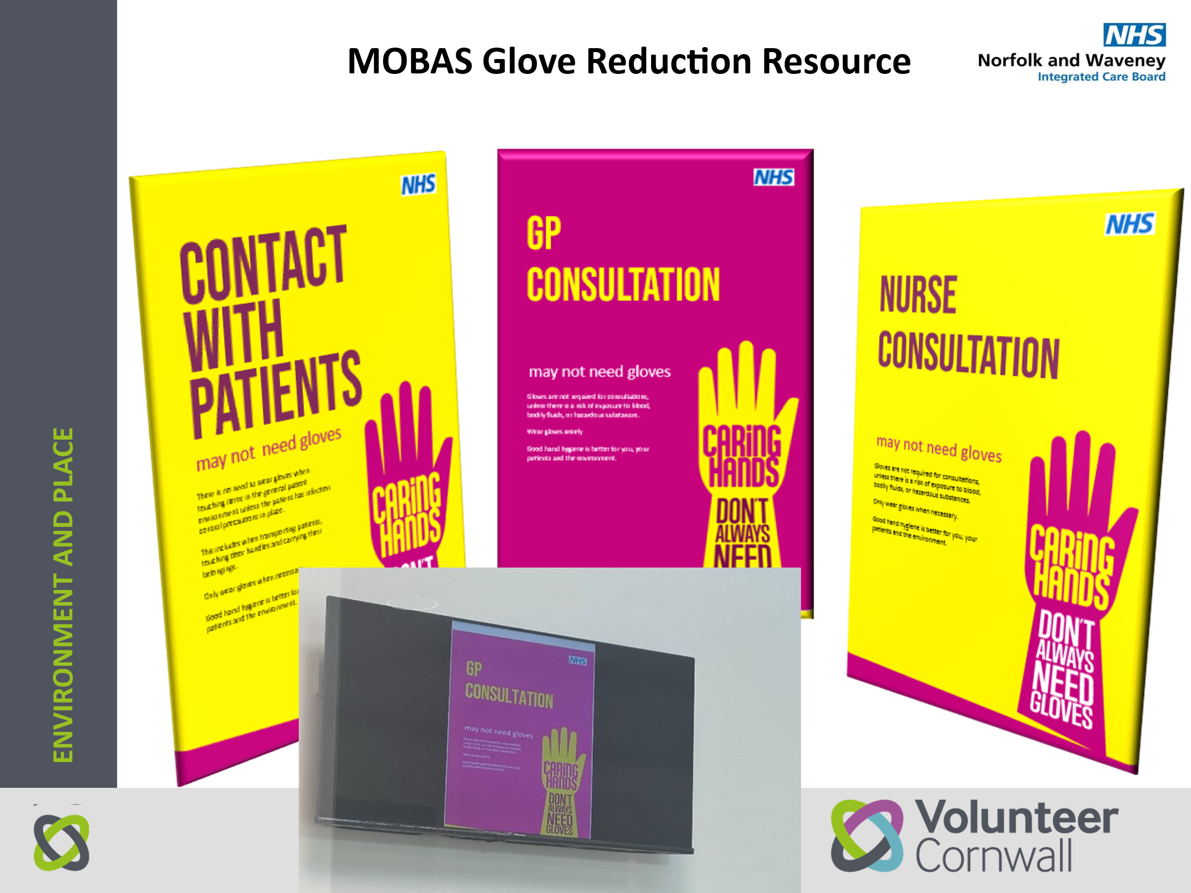
Questionnaire Answers
Here is a list of the questions that the CIoS IPC team expect to have a ‘Yes’ response (i.e. gloves should be worn).
7 – to receive a sample at reception
9 – to take clinical waste sacks outside
11 – to prepare cleaning products
12 – bodily fluids
17 – taking blood sugar
18 – testing urine
19 – eye drops
20 – clinically manage a catheter
24 – cytotoxic medication
25 – MRSA screening
26 – MRSA positive patient

